Reporting No:2 Week No:2 From :20/05/2024 To :24/05/2024 College ID: 22IT116

Project Title:

**WEEKLY REPORT**

**Work done in last week ( Attach supporting Documents):**

1. 20/05/2024 Monday

* 9.30am to 11.30 am: Introduction to JSX and Actual browser running using babel

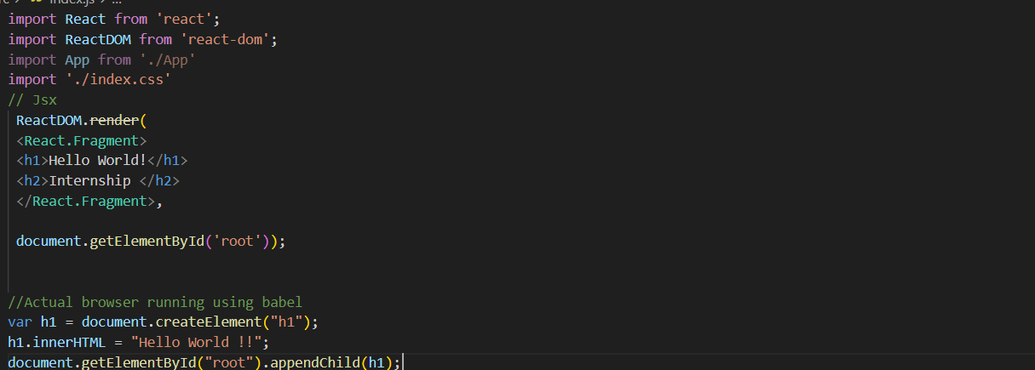

* 12.00pm to 2.30 pm: Mini project for creating List of 5 Movie and display in web

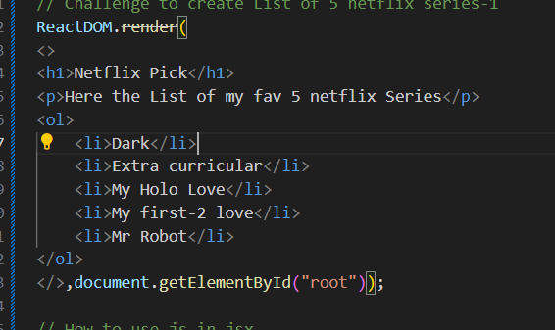

* 3.00 pm to 5.00 pm: How to use JS in JSX and Template Literals

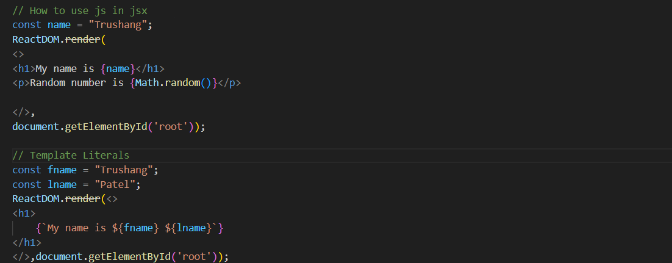

1. 21/05/2024 Tuesday

* 9.30am to 11.30 am: Creating a web page that show name

Today’s date and current time using JSX element

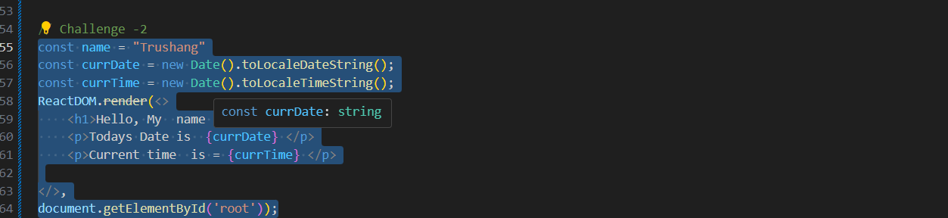

* 12.00pm to 2.30 pm: create a web site that generate 3 random image and add CSS Stying(External)

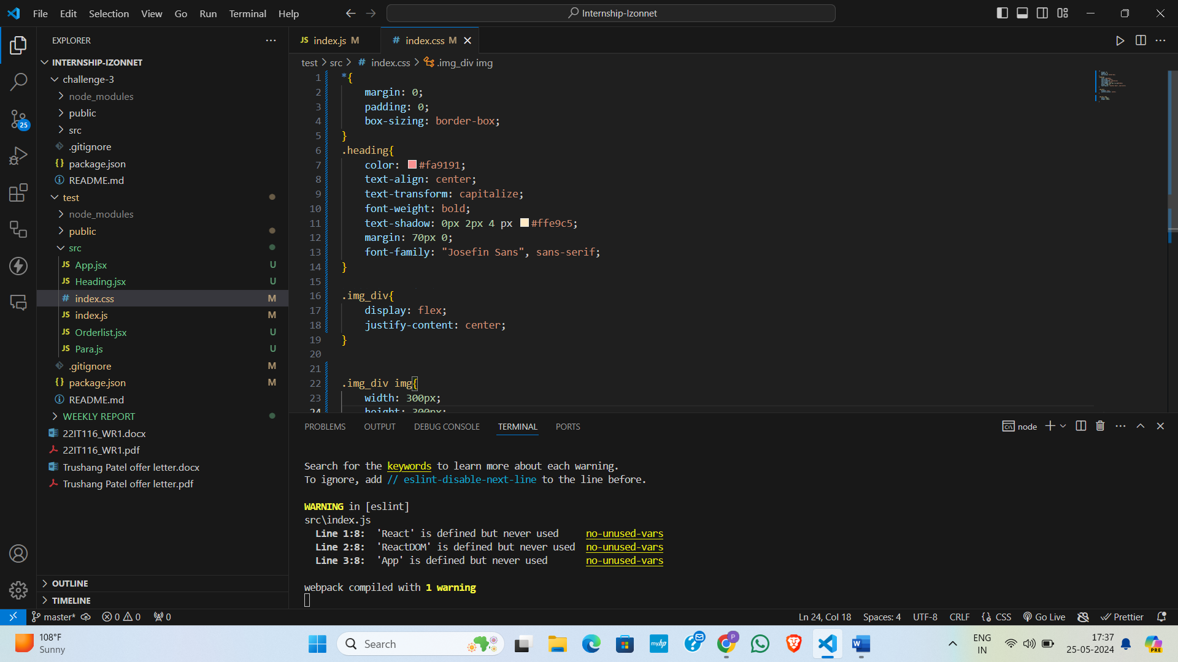

* 3.00 pm to 5.00 pm : Learn About Inline CSS styling

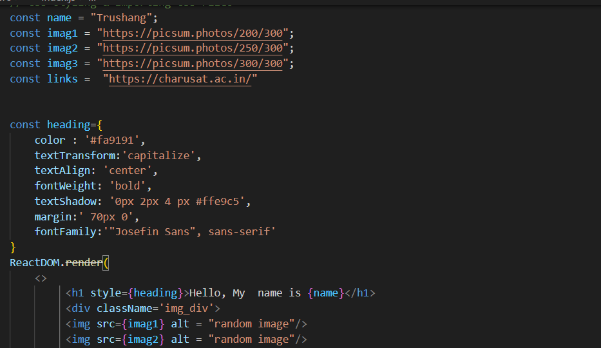

1. 22/05/2024 Wednesday

* 9.30 am to 11.30 am: Learn about components and why the use.
* 12.00pm to 2.30 pm: Implement the Components and create a simple website for greeting.

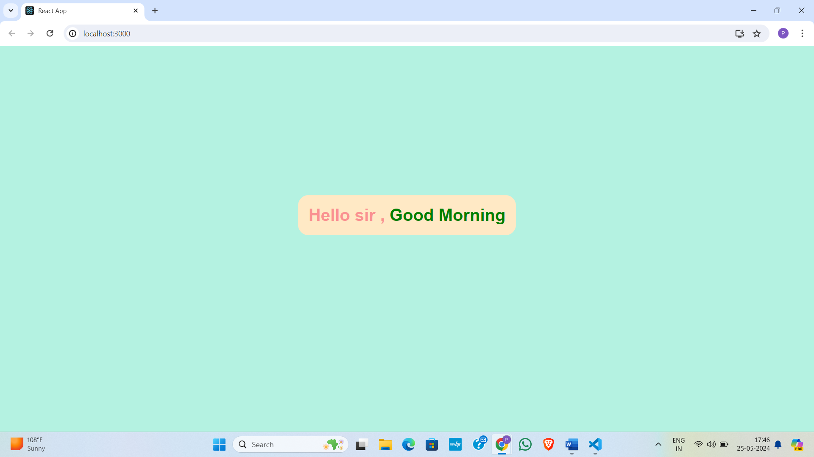

* 3.00 pm to 5.00 pm: Above created website we modify that code and create using components.

1. 23/05/2024 Thursday

* 9.30 am to 11.30 am: Learn about how to use Google fonts in our react project and props
* 12.00pm to 2.30 pm: Hooks in React js and using Hooks create a digital clock
* 3.00pm to 5.00 pm: Event Handling and Forms in React js

1. 24/05/2024 Friday

* 9.30 am to 11.30 am: How to use Material UI in our Project
* 12.00pm to 2.30 pm: How to install and use bootstrap
* 3.00pm to 5.00 pm: Learn React Router

**Plans for next week:**

1. To learn backend part for our website

**References:**

1. YouTube Channel: [Thapa Technical](https://www.youtube.com/@ThapaTechnical)
2. React Documentation

**Signature of External Guide Signature of Internal Guide**

Student Id: 22IT116

Student Name: TRUSHANGKUMAR SUMANBHAI PATEL